

Informatics Institute of Technology
Department of Computing

Course eg: Bsc Software Engineering

Module: 4COSC0011C Web Design & Development

Module Leader: Ms. Aloka Fernando

Group Coursework Report

Tutorial Group | : SE group A L4
Coursework Group No : <<according to google sheet>>
Student IIT ID | :
Student UoW ID | :
Student First Name | :
Student Surname | :

1. | Introduction ........................................................................................................................................................ |  | 3
2. | Technical Discussion ........................................................................................................................................... |  | 3
 |  | Presentation Page ....................................................................................................................................... | 3
 |  | Main Page ..................................................................................................................................................... | 3
 |  | Font size change .......................................................................................................................................... | 3
 |  | Comments Form .......................................................................................................................................... | 3
 |  | Buy products ................................................................................................................................................. | 3
 |  | Quiz ................................................................................................................................................................ | 3
View images and change text/background colour .................................................................................. |  |  | 3
3. | Discussion of UI and application of UX principles .............................................................................................. |  | 3
3.1 Information architecture .................................................................................................................................. |  |  | 4
 | a. Design ............................................................................................................................................................. |  | 4
 | b. Code to achieve good Information architecture ............................................................................................ |  | 4
3.2 Colour balance/composition/graphics/consistency ......................................................................................... |  |  | 4
 | a. Design ............................................................................................................................................................. |  | 4
 | b. Code to achieve good colour balance & ensure consistency ......................................................................... |  | 4
3.3 |  | Typography / consistency ........................................................................................................................... | 4
 | a. Design ............................................................................................................................................................. |  | 4
 | b. Code to achieve good typography / consistency ........................................................................................... |  | 5
3.4 Gestalt principles grouping ............................................................................................................................... |  |  | 5
3.5 Accessibility (graphics/forms)........................................................................................................................... |  |  | 7
 | a. Graphical elements - Design/Code ................................................................................................................. |  | 7
 | b. Form completion - Design/Code .................................................................................................................... |  | 7
3.6 Error prevention and recovery ......................................................................................................................... |  |  | 7
 | a. Design ............................................................................................................................................................. |  | 7
 | b. Code to address error prevention and recovery ............................................................................................ |  | 8
4 | Janet ................................................................................................................................................................... |  | 8
5 | Conclusions ......................................................................................................................................................... |  | 8
References .................................................................................................................................................................. |  |  | 8
Appendices ................................................................................................................................................................. |  |  | 8
Appendix A: Code ................................................................................................................................................... |  |  | 8
Appendix B: Screenshots ........................................................................................................................................ |  |  | 8
Appendix C: Individual Statement .......................................................................................................................... |  |  | 9

1. Introduction

Website Topic – “Football Corner”

Team Members
- Chiran Ranatunga 2018814 (Group Leader)
- Anushka Alwis 2018088
- Sahan Liyangaskumbura 2018819
- Karthikean Nishenthan 2018844

2. Technical Discussion

Discuss the development of the tasks that you were allocated. This technical discussion must include the approach taken, and explanations of how the required functionality was implemented. Illustrate your explanation with code snippets and screenshots. Also explain the difficulties you faced and how you solved them.

Illustrate your technical discussion with screenshots and code samples.

Student Number – Student 03

Task 1 – Making the Quiz
Approach taken
- The quizzes and the answers were made as JavaScript objects
- The command / manipulation buttons were made using HTML
- CSS division method was used to contain the questions and timer
- The quizzes were extracted from Online medium.

Implementation (add screens)

- Quizzes are in JavaScript objects. JavaScript functions are used to call the objects.
- The interval to call/ display the questions was 10 seconds.
- The user’s mouse clicks are assigned as functions and assigned to JavaScript objects
- “Correct” answer increases the “correct counter, “incorrect” answer increases the “incorrect counter”
- Correct answers changes the circle colour to green, incorrect is shown in red. “If” conditions are used in this procedure.
- Correct answers are allocated 2 marks each. Incorrect marks are allocated -1 mark each.
- The Turnery operator is used to determine the marks percentage.
- To get the score percentage as a whole number max.around operator is used.
- Marks>50 = Green colour | Marks<50 Red colour
- Finally, Student 1’s “Text size incrementor” was added to this page.

Difficulties and solving strategy

Difficulty | Solving Strategy
Figuring out the quiz answer option alignment strategy | Initial idea was to implement it based on waterfall alignment method. Later discussions with Sahan lead to display the quiz options horizontally and vertically aligned so that it adheres to standard UI principles.
Problem of displaying marks as minus values (The question “is it a standard practice?” was arised) | Display the marks as “0” if it comes to minus as a standard. But display the minus value for the user in terms of awareness.

Add UI screenshots
Task 2 – Student Details Page

Approach taken
- Mouse over and mouse and mouse out events are used to trigger the show description function

Implementation
- The four pictures were displayed using “float” method.
- Mouse over and mouse and mouse out events are used to trigger the show description function
- Switch cases are used to determine the mouse pointer
- Use cases are used to determine the mouse point

Difficulties and Solving Strategy

Difficulty | Solving Strategy
Avoiding white spaces | Using background image slideshow to counter the excess white space .

Task 3 – CV

Approach Taken
- HTML was used to display the content
- CSS was used for styling and alignment
- The content was taken from the existing personal CV

Implementation
- The above approach was taken to assign the correct content to each section and align them accordingly.

Difficulties and Solving Strategy

-

Add screens

- Discussion of UI and application of UX principles

Explain how you met the following UX principles to achieve a good aesthetical result, appealing to the target audience of the web site, with good visual balance between all the UI elements (background, header, footer, text, borders, graphics etc.), making content legible, clear and discoverable.

Illustrate each of your discussion with screenshots and code samples.

Max 1000 words
3.1 Information architecture

a. Design

Explain how you structured the web site (the organization of the web site folders) and how you designed the web site navigation to ensure that content is discoverable, that users are aware at any time of their position (use of breadcrumb or breadcrumb trail) on the web site and they can easily (with the minimum number of steps) to jump to different sections of the web site. Did you consider how you can assist the users to search for content?

How did you implement the web site navigation system? Provide relevant HTML & CSS code.

How do you structure each page to direct the user to content (when multiple pages use the same style you need to explain only the template that those pages follow)? Do you differentiate the importance of content (e.g. primary, footnotes)?

b. Code to achieve good Information architecture

For example the template created for your individual pages and for navigation.

3.2 Colour balance/composition/graphics/consistency

a. Design

Explain the colour combination, the composition (visual structural elements) and graphics (images, logo, icons) you used to ensure the proposed web site is appealing for its purpose, it reveals its’ identify and complies with the brand.

good aesthetical result such as good visual balance between all the UI elements (background, header, footer, text, borders etc.) and also ensure good legibility of the web site.

b. Code to achieve good colour balance & ensure consistency

What CSS did you write to ensure good and consistent colour balance

What HTML code you wrote to structure your we site in order to ensure good and consistent composition

Did you write any CSS to consistently format the appearance of graphics?

3.3 Typography / consistency

a. Design

Explain the fonts, font sizes, colours and styles you used to ensure the proposed web site is appealing and suitable for its purpose and at the same time legible. Explain how you ensured content relevance and consistency (e.g. paragraph titles, subtitles, text, small font).

b. Code to achieve good typography / consistency

What CSS you created to modify text.

Did you use any of the online tools to test the legibility of your web site? What were the test results?

How did you write the CSS to ensure consistency?

3.4 Gestalt principles grouping

How did you apply the Gestalt principles of grouping to reveal the purpose of the content, to direct the user to content and to increase the legibility of your web site? Use screenshots of your page to better support your justification.

E.g. for the example below you could write something like that:
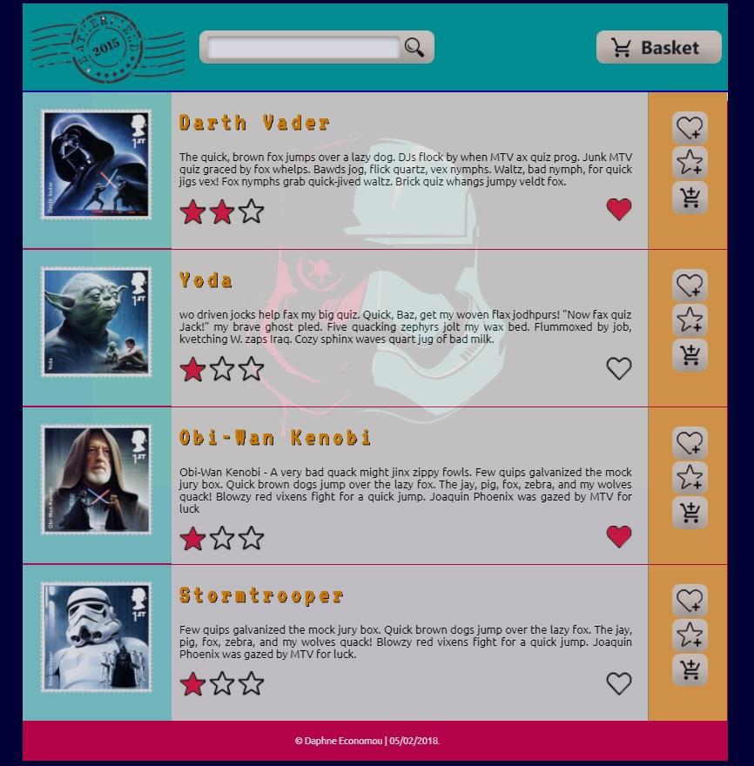

In the above example proximity that states that "objects or shapes that are close to one another appear to form groups” has been applied in the following elements:

- aligning the title, textual description for each stamp and rating star graphics close to each other creates a group, aligning this group of elements next to the stamp graphic creates a relation of the description to the stamp. Similarly aligning the favourite, rating and add to basket icons close to each other makes them a group. Aligning the stamp (blue box), the description (grey box), and icons (orange box) next to each other creates a relevance between those elements.

- leaving space vertically between each stamp, description and icons box separates the stamps, their description and the icons to interact with each stamp respectively.

In addition closure is applied by drawing a line between stamps makes those groups more explicit. Placing the stamp inside a blue box, the description in a grey box, and icons in the orange box is another way of applying closure to make more explicit that this content belongs in the same group.
Closure is also applied by drawing a line after the header and by using different colours in the header, footer and the main part of the page (container) to make the type of content more explicit and to enhance legibility and discoverability.

Continuation users "tend to continue shapes beyond their ending points". The box that contain the stamp thumbnail, the stamp description related icons and buttons, appear in discrete boxes with different colour, however we tend to perceive that those boxes are enclosed in a wider box.

Similarity stands for the things which share visual characteristics such as shape, size, colour, texture, or value will be seen as belonging together in the viewer’s mind. In this example this principle is applied by repeating the same style to the boxes that contain the stamp thumbnail, the stamp description and related icons and buttons indicate that enclosed content is of similar type.

3.5 Accessibility (graphics/forms)

a. Graphical elements - Design/Code

Explain how you addressed accessibility on the design of the web site. For example for the following graphical elements what accessibility tags have been used in order to make sure that in case that the graphics cannot be displayed the users would still get the required information and would still be able to interact with buttons and icons.
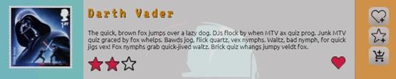

b. Form completion - Design/Code

State how you ensure good accessibility, for example in form completion. Explain the tags you used.

3.6 Error prevention and recovery

a. Design

In cases of form completing how did you assist the user to complete all the required field, to enter the information correctly and eliminate error and how did you address error recovery? For example did you use any instructions for completing the form? Did you provide any meaningful error messages in case the users did not completed the form correctly to help them correct their mistakes?

How have you addressed accessibility in the design. For example instructions for form completion, inclusion of images for descriptive or decorative purposes, or system response and error messages.

Illustrate your discussion with screenshots.

b. Code to address error prevention and recovery

Provide the code you used to address accessibility, e.g. for form completion, graphics, or system response and error messages.

4 Janet

Explain how your web site complied with Janet Regulations, Janet Policies and Legal Requirements. Max 200 words

5 Conclusions

This should include reflection on the work carried out, how you worked as a team, problems encountered as part of your technical development lessons learnt and suggested improvements.

References

Provide references to resources you may have used

Appendices

Appendix A: Code

Provide a full listing of your files, with well indented and commented code in the following format:

Filename

Code

Appendix B: Screenshots

Provide a screenshot of all your web pages, in the following format:

Filename

Screenshot(s)
Appendix C: Individual Statement


 | Student Name: |  | Student Id:
 | State what tasks you carried out in the project.

State what you enjoyed and did not enjoy about teamwork.

State what you learnt about teamwork.

State what skills you gained/learnt from undertaking the project.

State any strengths about yourself that emerged whilst undertaking the project.


State any weaknesses about yourself that emerged whilst undertaking the project.

State how you would do things better if you were to undertake the project again.

Additional general or project specific comments:

 | Student |  | Date:
 | Signature:

